To,
The Heads of the Institutions
Affiliated to CBSE
Subject - Offering skill knowledge courses to impart various skill to students as per CBSE
Dear Principal,
I am writing to propose an innovative new program for your school that I believe will benefit your student in a variety of ways. I believe that this program will help your students to excel academically, socially, and virtually.
Through this, the student will have the opportunity to develop their leadership and communication skills, while also gaining valuable experience working with us. On the other hand, will benefit from having a positive role model in their lives, and will be able to dev elope important social and virtual skills through their interactions with our mentors.
A focus on individualized learning: Every student learns differently, so the school should focus on creating personalized learning plans for each student. This could include assessments to identify each student’s strengths and weaknesses, and then tailoring the curriculum to match their individual needs.
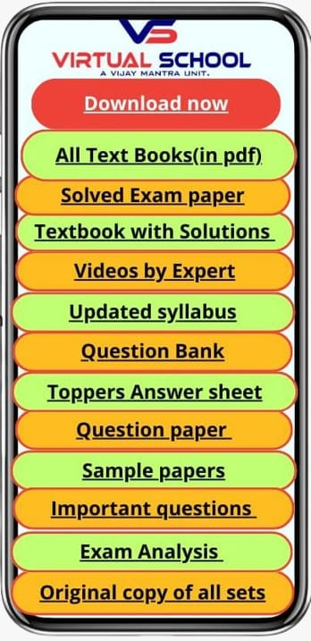
Key benefit:-
Admission classes Nursery to 9th & 11th
Social media marketing and promotion
Student counseling (expert)
Virtual school application (6to12) that contains:-
Textbooks with solution
Ideal solutions are provided for practice and self-study.

All textbooks (in pdf)
All NCERT text books, reference books and lab manuals available for download.

Updated syllabus
Every year revised syllabus is made available for student’s record and download.

Videos by experts
Hand-picked video collections from the best.

Sample papers
Practice more with provided sample papers and add yours too!

Question bank
Practice make you perfect. So does smart studies.

Original copies of all sets
How about preparing with real ones?

Solved CBSE exam paper (12 years)
Understand the pattern from previous papers and prepare for what’s coming ahead.

Exam analysis
In-depth analysis to understand importance and weightage chapter-wise and topic wise.

Topper’s answer sheet
Know what they did to succeed and learn the blueprint.

Important questions
Questions marked important by our experts, previous students or asked multiple times in boards.

In-app community
A place where all the students meet and share important content, ideas and a lot more, everything within the app.

For more details kindly give us your valuable time to discuss more about the program, I look forward to the possibility of collaborating with you.
Thank you for your consideration.

Best Regards,
Vijay Mantra

